Sinh viên : Vũ Văn Trọng

Mã Số Sinh viên : 20184206

ASSIGNMENT 1

.eqv SEVENSEG_LEFT 0xFFFF0011 # Dia chi cua den led 7 doan trai.

# Bit 0 = doan a;

# Bit 1 = doan b; ...

# Bit 7 = dau .

.eqv SEVENSEG_RIGHT 0xFFFF0010 # Dia chi cua den led 7 doan phai

.text

main:

li $a0, 0x8 # set value for segments

jal SHOW_7SEG_LEFT # show

nop

li $a0, 0x1F # set value for segments

jal SHOW_7SEG_RIGHT # show

nop

exit: li $v0, 10

syscall

endmain:

#---------------------------------------------------------------

# Function SHOW_7SEG_LEFT : turn on/off the 7seg

# param[in] $a0 value to shown

# remark $t0 changed

#---------------------------------------------------------------

SHOW_7SEG_LEFT: li $t0, SEVENSEG_LEFT # assign port's address

sb $a0, 0($t0) # assign new value

nop

jr $ra

nop

#---------------------------------------------------------------

# Function SHOW_7SEG_RIGHT : turn on/off the 7seg

# param[in] $a0 value to shown

# remark $t0 changed

#---------------------------------------------------------------

SHOW_7SEG_RIGHT: li $t0, SEVENSEG_RIGHT # assign port's address

sb $a0, 0($t0) # assign new value

nop

jr $ra

nop

* Bảng Text Segment :

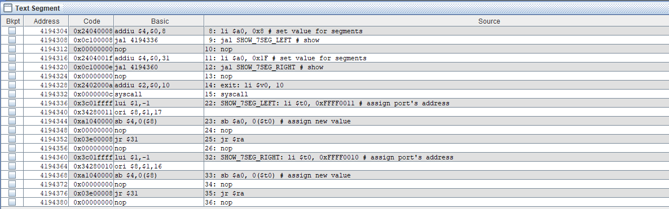

* Kết quả :

